

Builder/Developeroverview here with information specific to the builder/developer

**About This Project and its Key Features**

These have to be specific to the project that is being marketed.

Program (Single Family, Multifamily, Commercial, etc)

EarthCraft Gold/Platinum Certified.

EarthCraft Score: _______

HERS Index _______

Key Features and Details:

High Performance Building Envelope

* Continuous exterior insulation R-3 reduces thermal bridging (benefit to homeowners - additional comfort and energy savings) Conditioned crawl space (benefits to homeowners - no more mold or moisture problems, additional comfort, no more cold floors)

Energy Efficiency:

* HVAC performance testing resulted in X% total duct leakage
* Advanced lighting (XX% CFL’s)
* Energy Star dishwasher and refrigerator

HEADER/ADDRESS

*About your commitment to Sustainability, working with Viridiant, choosing the EarthCraft program, etc*

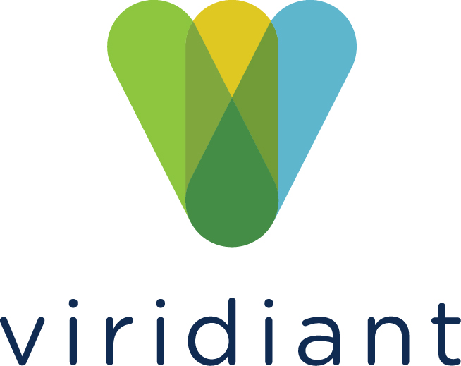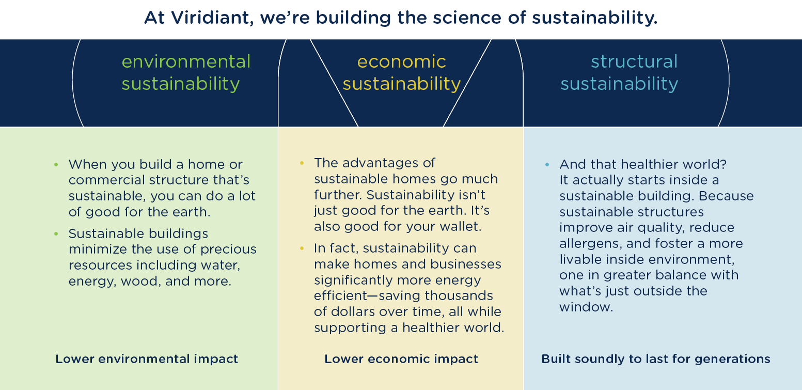

John Doe Builders – xxx St, City, State – (804) 555-5555 – Website